EMR Cluster created:

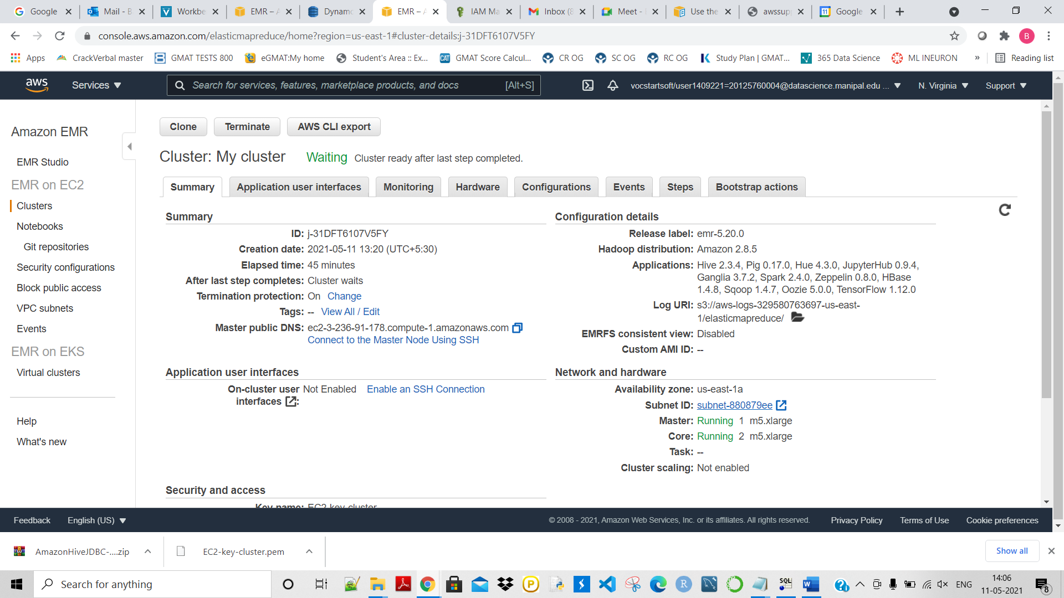

The above cluster is created then connected to the SQL workbench:

